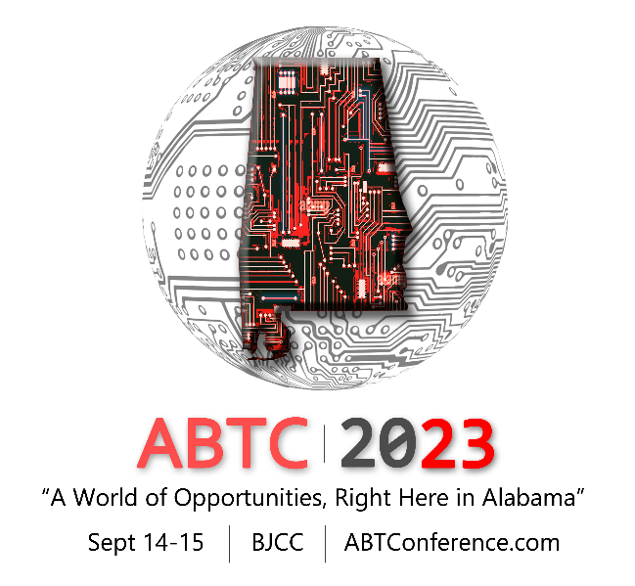
ABTC 2023 Call for Presentations

Let your organization play a larger role at the 2nd Annual Alabama Business Technology Conference! Submit your paper to be one of our breakout presenters and help shape Alabama’s private, public, government and education sectors with your Workforce, Innovation, Security and/or Technology knowledge. Bring your new products to the table!
Submissions are now being accepted for presenters at the ABTC.
Preliminary areas of focus are:
• Workforce, Governance, Risk & Compliance: Workforce Development (Attracting Talent and keeping talent); UX/UI; Regulatory Requirements, Issues & Compliance; Risk Management; Project Management Solutions and Tools; Data Security in Financial Services; Dev-Ops;
• Innovation: Artificial Intelligence: 5G & The Future; Blockchain & Cryptocurrency Technology; Biotech & Genomics Technology; Digital Transformation; Robotics; Smart buildings; Cloud Technology; Disaster Recovery & Backup Solutions using cloud options; Software define solutions
• Security: Cyber Security automation using AI that Works; Data security in Financial Services; Security Architecture & Engineering; Securing your Cloud Environment; Software Security; Network Security; Emerging Cyber Threats
• Technology: Hardware & Enterprise Network Solutions; Edge of IoT, Software Solutions & Devices; Data Optimization & Analytics & Big Data; Facility Management Software / Supply Chain Management; Real Time AI

Please complete and submit this form to info@alabamatechnologyfoundation.org.

Date: __________________

Email: ___________________________________________

First Name: _________________________________

Middle: _________________________________

Last Name: _________________________________

Company/Organization Name*:

Job Title: _________________________________

Work Phone: _______________________________

Cell Phone: _______________________________

Address 1: ____________________________________________

Address 2: ____________________________________________

City: _______________________________

State: _______________________________

Zip: _________________

Please mark all the dates you are available to present

Thursday, September 14th ___
Friday, September 15th ___

Please select a theme or topic area

Workforce, Governance,
Risk & Compliance ___
Innovation ___
Security ___
Technology ___

Please enter your presentation title*

Please enter a brief description of your presentation *

________________________________________________________________________________________________________________________________________________________________________________________________________________________________________________________________________________________________________________________________________________________________________________________________________________________________________________________________________________________________________________________________________________________________________________________________________________________________________________________________________________________________________________________________________________________________________________________________________________________________________________________________

Will you have co-presenter(s)? Circle one.
No
Yes
If yes, please list their names: ________________________________________________________________________________________________________________________________

Please email all bios and headshots with application.

Do you require Audio Visual support?
No
Yes
Maybe

If yes or maybe, please list your AV needs below:

________________________________________________________________________________________________________________________________________________________________________________________________________________________________________________________________

