Kelly Creek Commerce Park Officially Opens
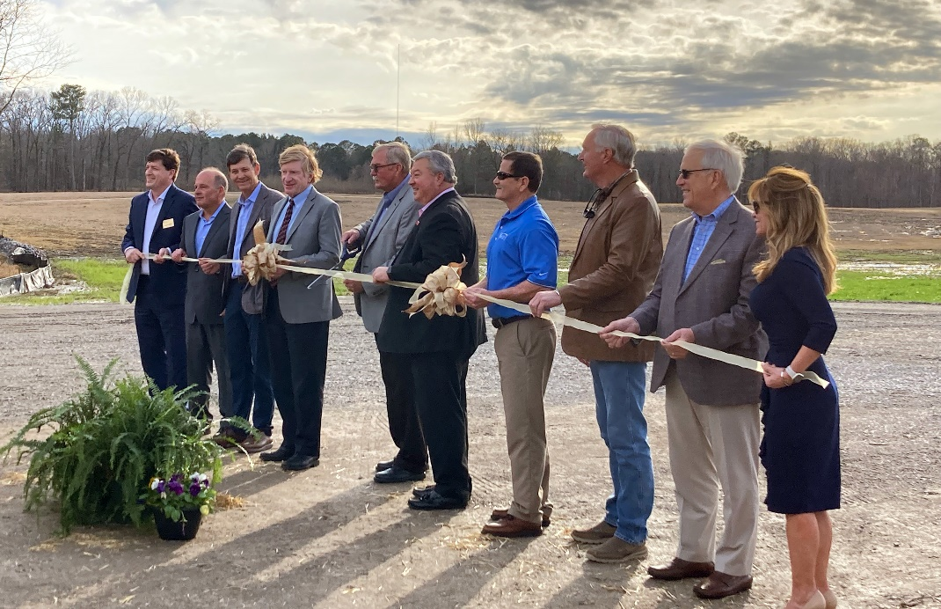
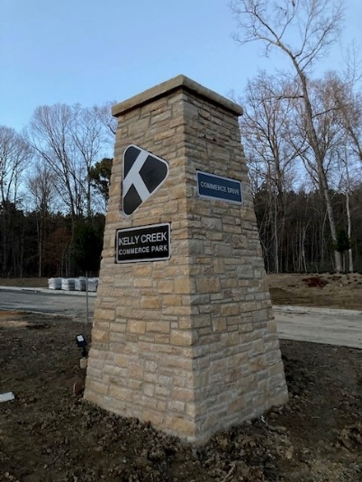
The City of Moody and the St. Clair County Economic Development Council held a ribbon cutting ceremony for Kelly Creek Commerce Park Thursday, February 9th. Kelly Creek Commerce Park is a 172-acre park designed for corporate headquarters, manufacturers, and distribution companies. Kelly Creek is a joint venture with the city, Capstone Real Estate Investments and Graham & Co. and features quality infrastructure and prepared sites, which provide faster construction timelines. This site represents the largest park of available sites for large employers in St. Clair County.
“Having industry-ready sites is a high priority for Alabama’s economic development team today, and the opening of the Kelly Creek Commerce Park in Moody gives us another valuable resource as we pursue growth projects that create jobs for the state’s citizens,” said Greg Canfield, Secretary of the Alabama Department of Commerce.
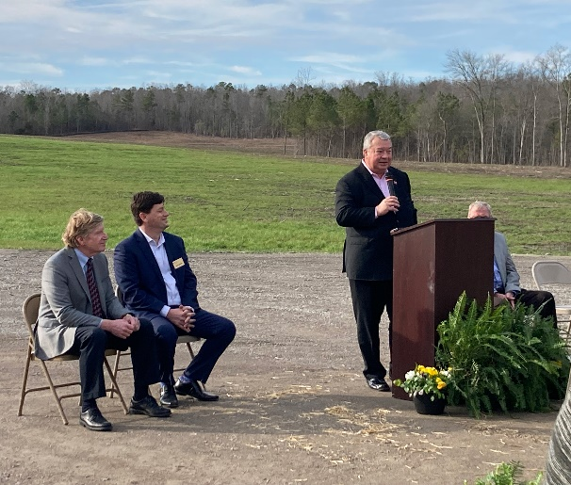
More than two years of planning and preliminary work have gone into this project. According to Don Smith, Executive Director of the St. Clair County EDC, the state’s Growing Alabama program played a large role in having this location available for 5-6 new companies to join the community.
“The vision from the beginning has been to offer shovel ready sites for quality projects looking to bring jobs and capital investment to a first-class environment. For sure, this is a great community in which to do business, both city and county. There is a reasonable taxation and fantastic interstate access. With over 100 acres already cleared with quality new infrastructure, Kelly Creek Commerce Park offers another important attribute in readiness. When companies are looking at sites and communities for their projects, they are looking for all the great things Kelly Creek Commerce Park has to offer, but readiness is what sets you apart.” added Mike Graham of Graham & Co., developer of Kelly Creek Commerce Park.

